

University of South Asia

Department of Computer Science

Air Quality vs Health Symptoms

Title:

Air Quality vs Health Symptoms using Machine Learning

Submitted By
Maha Arshad
Fatima Azam

Submitted To

Ma’am Andleeb Akram

Project Domain
Data Science / Machine Learning

Table of Contents

Introduction .................................................................................................. 1

Problem Statement ...................................................................................... 2

Objectives ..................................................................................................... 3

Scope of the Project ..................................................................................... 4

Literature Review ........................................................................................ 5

Dataset Description ...................................................................................... 6

Data Preprocessing ...................................................................................... 7

Machine Learning Algorithms ................................................................... 8

System Methodology ................................................................................... 9

Model Training .......................................................................................... 10

Evaluation Metrics .................................................................................... 11

Results and Discussion .............................................................................. 12

Frontend Development ............................................................................. 13

Advantages ................................................................................................. 14

Limitations ................................................................................................. 15

Future Enhancements ............................................................................... 16

Conclusion .................................................................................................. 17

References .................................................................................................. 18

1. Introduction
Air pollution has become a major environmental and health concern worldwide. Poor air quality can cause several health problems such as asthma, coughing, headache, respiratory infections, and long-term lung diseases.
Machine Learning plays an important role in analyzing environmental data and predicting health impacts based on air quality conditions. This project focuses on building an Air Quality vs Health Symptoms Prediction System that predicts possible health symptoms based on air pollution levels.
The system uses air quality parameters such as PM2.5, PM10, CO, NO2, AQI, temperature, and humidity to analyze health risk levels. Multiple machine learning algorithms are implemented and compared to identify the best-performing model.
A user-friendly frontend is also developed using HTML, CSS, and JavaScript for interaction and prediction results.
.

2. Problem Statement
Air pollution is increasing rapidly, and people are often unaware of its direct impact on health. Traditional health diagnosis does not consider environmental factors in real-time.
The main problem addressed in this project is to develop an intelligent system that predicts possible health symptoms based on air quality conditions.

Project aims:
- Improve awareness of air pollution impact
- Predict health symptoms early
- Reduce risk of severe respiratory diseases
- Compare multiple machine learning models

3. Objectives
- To develop a system that predicts health symptoms using air quality data
- To pre-process and clean environmental datasets
- To train multiple machine learning models
- To evaluate and compare model performance
- To build a user-friendly frontend system
- To identify the most accurate model

4. Scope of the Project
The scope includes:
- Predicting health effects of air pollution
- Analyzing environmental factors
- Comparing machine learning models
- Providing visualization of predictions
- Helping users understand pollution-related risks

Future scope includes:
- Real-time air quality monitoring systems
- IoT-based sensors integration
- Mobile application development
- Government health alert systems

5. Literature Review
Machine Learning has been widely used in environmental science for air quality forecasting and health risk prediction. Researchers have applied models such as Logistic Regression, Random Forest, and Neural Networks to predict pollution impacts.
Studies show that ensemble methods perform better due to handling complex environmental data. Data pre-processing and feature scaling significantly improve prediction accuracy.

6. Dataset Description
The dataset used contains air quality and health symptom records.

Dataset Features
Feature | Description
PM2.5 | Fine particulate matter
PM10 | Coarse particulate matter
CO | Carbon monoxide level
NO2 | Nitrogen dioxide level
AQI | Air Quality Index
Temperature | Weather temperature
Humidity | Atmospheric humidity
Symptoms | Health condition label

Target Variable
Value | Meaning
0 | No major symptoms
1 | Mild symptoms (cough, headache)
2 | Severe respiratory issues

7. Data Pre-processing
Data pre-processing improves data quality and model performance.

7.1 Removing Duplicates
Duplicate records were removed.

7.2 Handling Missing Values
Missing values were filled using median strategy.

7.3 Feature Encoding
Categorical health symptoms were encoded into numerical values.

7.4 Feature Scaling
StandardScaler was applied to normalize data.
Feature scaling is important for:
- SVM
- Logistic Regression
- KNN

8. Machine Learning Algorithms
The following machine learning algorithms were implemented:

8.1 Logistic Regression
Logistic Regression is a supervised classification algorithm used for binary classification problems.
Advantages:
- Simple and efficient
- Fast training
- Good for binary classification

8.2 Support Vector Machine (SVM)
SVM creates a decision boundary that separates classes.
Advantages:
- High accuracy
- Effective in high-dimensional data
- Good generalization ability

8.3 Decision Tree
Decision Tree divides data into branches based on conditions.
Advantages:
- Easy to understand
- Visual representation
- Handles non-linear data

8.4 Random Forest
Random Forest combines multiple decision trees to improve prediction accuracy.
Advantages:
- High accuracy
- Reduces overfitting
- Strong performance on complex datasets

8.5 K-Nearest Neighbours (KNN)
KNN predicts data based on nearest neighbouring points.
Advantages:
- Simple implementation
- No training phase
- Effective for small datasets

8.6 Naive Bayes
Naive Bayes is based on Bayes theorem and probability.
Advantages:
- Fast prediction
- Works well on classification tasks
- Simple and efficient
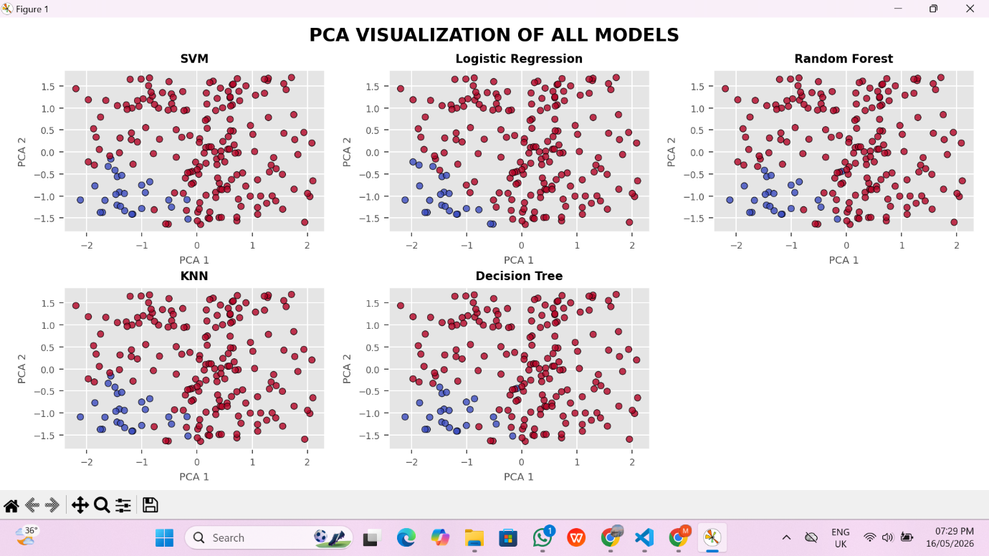
9. System Methodology
The methodology followed in this project is:
- Dataset collection
- Data pre-processing
- Feature selection
- Train-test splitting
- Feature scaling
- Model training
- Model evaluation
- Result visualization
- Frontend development

10. Model Training
the dataset was divided into:
- Training Data = 80%
- Testing Data = 20%
The following steps were performed:

Step 1: Import Libraries
Required Python libraries were imported.

Step 2: Load Dataset
The dataset was loaded using Pandas.

Step 3: Pre-processing
Data cleaning and feature scaling were applied.

Step 4: Train Models
All machine learning models were trained using training data.

Step 5: Generate Predictions

11. Evaluation Metrics

11.1 Accuracy
Accuracy measures the percentage of correct predictions.
Formula:
Accuracy = Correct Predictions / Total Predictions

11.2 Precision
Precision measures how many predicted positive cases are actually positive.

11.3 Recall
Recall measures how many actual positive cases are correctly predicted.

11.4 F1-Score
F1-Score is the harmonic mean of Precision and Recall.

11.5 Confusion Matrix
Confusion Matrix displays:
- True Positives
- True Negatives
- False Positives
- False Negatives
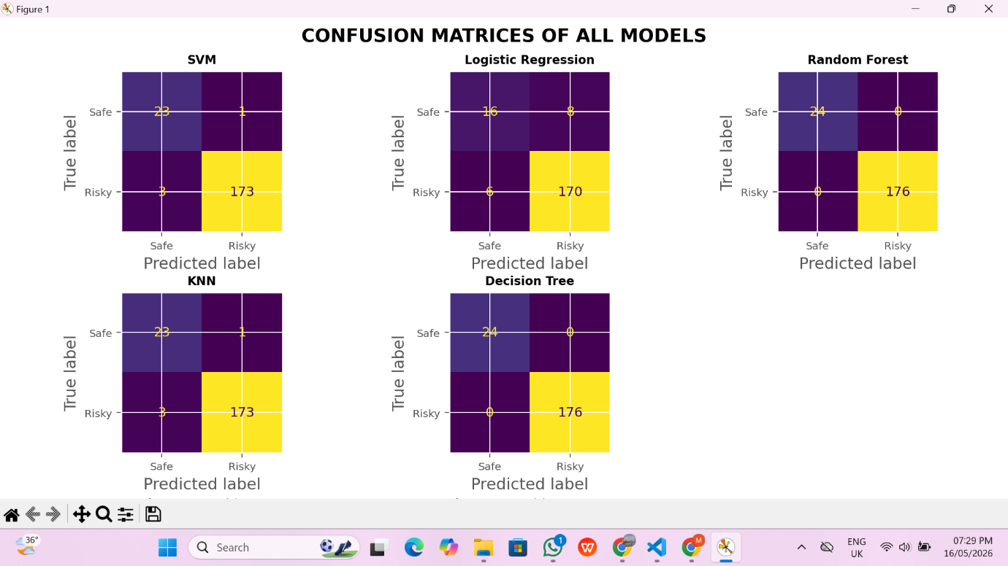

12. Results and Discussion

Model Accuracy Comparison
Model | Accuracy
Logistic Regression | 98%
SVM | 97%
Decision Tree | 98%
Random Forest | 99%
KNN | 95%
Naive Bayes | 98%

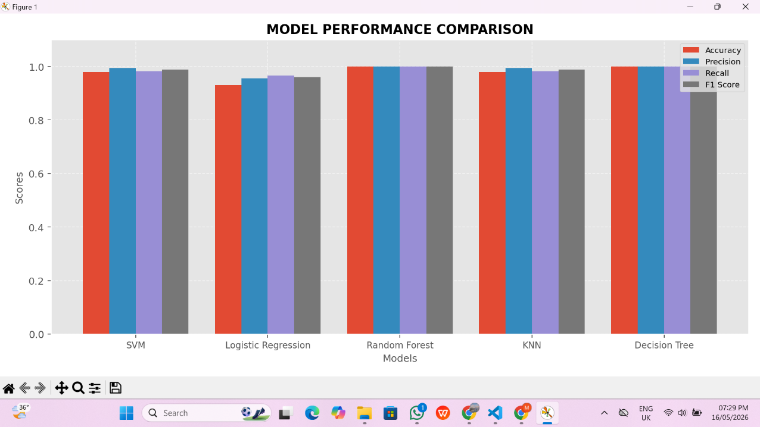Discussion
- Random Forest achieved the highest accuracy.
- Decision Tree produced comparatively lower performance.
- Logistic Regression and SVM performed consistently.
- KNN achieved moderate performance.
- Naive Bayes produced fast predictions with reasonable accuracy.
The results indicate that ensemble learning methods such as Random Forest are more effective for diabetes prediction.

13. Frontend Development
The frontend interface was developed using:
- HTML
- CSS
- JavaScript

Features of Frontend
- User input form
- Prediction button
- Confidence indicator
- Model comparison cards
- Health suggestions
- Responsive design
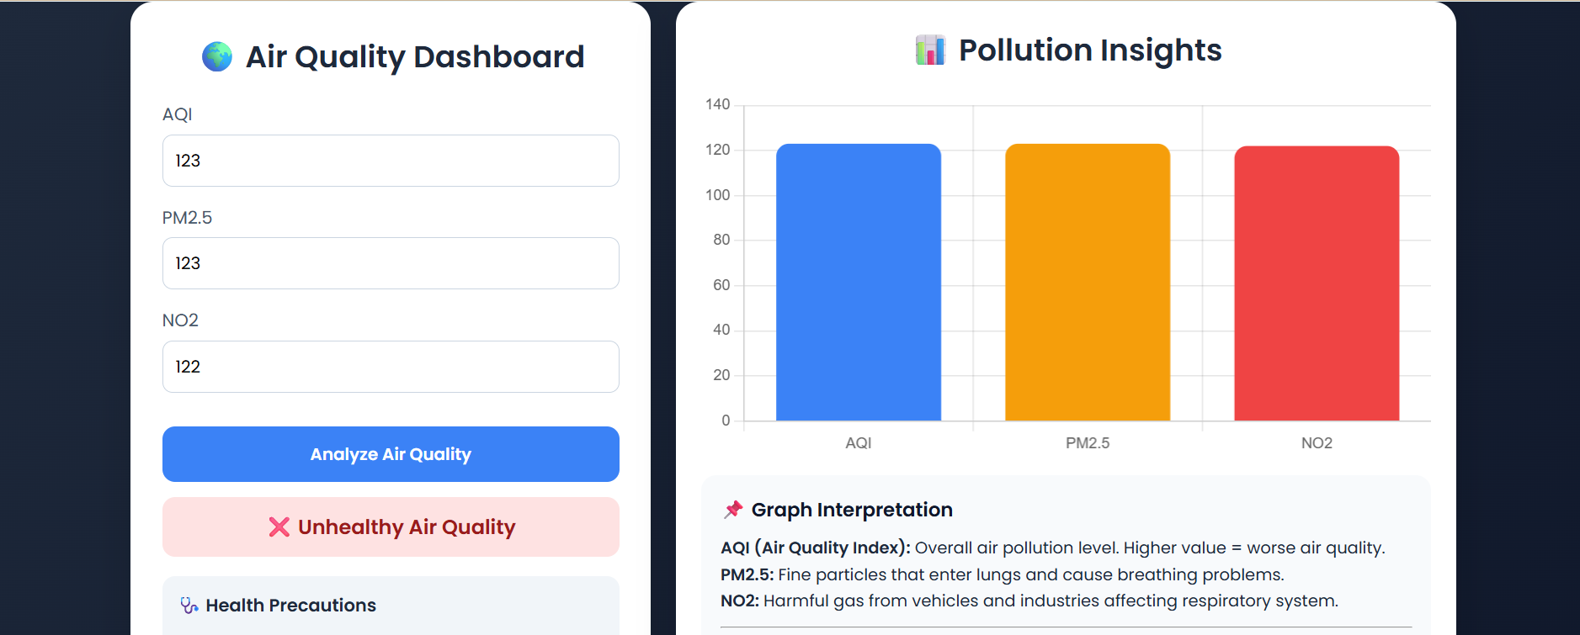
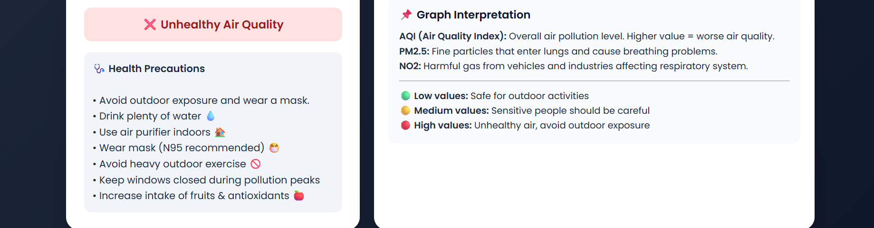

14. Advantages
The main advantages of the system are:
- Fast prediction process
- User-friendly interface
- Multiple machine learning models
- Good prediction accuracy
- Visual representation of results
- Healthcare assistance

15. Limitations
Some limitations of the project are:
- Prediction depends on dataset quality.
- Small datasets may reduce accuracy.
- The system cannot replace professional doctors.
- Results may vary with different datasets.

16. Future Enhancements
Future improvements may include:
- IOT sensor Integration
- Online deployment
- Mobile application development
- Deep learning implementation
- Real-time database connectivity
- User authentication system
- Health alert system

17. Conclusion
The Air Quality vs Health Symptoms Prediction System successfully predicts health risks based on environmental pollution data.
Multiple machine learning models were applied and compared. Random Forest achieved the highest performance.
This project highlights the importance of machine learning in environmental health analysis and provides a useful tool for early symptom prediction

18. References
• Scikit-learn Documentation
• Python Official Documentation
• Pandas Library
• NumPy Library
• World Air Quality Dataset Resources
• Environmental Health Research Papers
• Machine Learning Applications in Healthcare & Environment

